**Multiclass Classification:**

NB can easily do multiclass classification and actually in first place it is designed for multiclass classification.

As we are calculating P(Y =0|W) or P(Y =1|W) , we can do it for “C” classes.

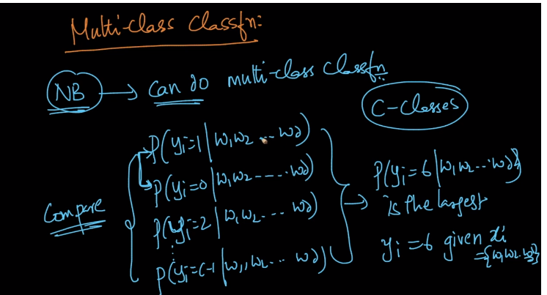

Comments:

